
Media contacts: Nicole Greason (English)
President, Arizona Latino Media Association
480-529-3714
Maritza L. Félix (Spanish)
NEWS RELEASE
480-297-2019
Board member, Arizona Latino Media Association

Arizona State Superintendent of Public Instruction Kathy Hoffman
to speak at Get Schooled: Covering Education Like a Pro, a conference presented
by Arizona Latino Media Association and Education Writers Association
March 2, 2019 in Phoenix
Phoenix, Arizona – Arizona State Superintendent of Public Instruction Kathy Hoffman will be featured in a Q&A session at Get Schooled: Covering Education Like a Pro, a conference for media and communications professionals on March 2 in Phoenix.
The conference, the first of its kind presented by the Arizona Latino Media Association and the Education Writers Association, is set for 9 a.m.-2:30 p.m. at the Arizona State University Walter Cronkite School of Journalism and Mass Communication. Admission to the conference is free.
Hoffman was elected State Superintendent of Public Instruction in November 2018, and assumed office in January 2019. Hoffman spent her entire career working in public education, first as a pre-school teacher and then as a speech-language pathologist. She began her career in the Vail School District in Southern Arizona before joining the Peoria School District.
In addition to an appearance by Hoffman, the conference will feature panel discussions on issues at the forefront of education today, including charter schools and choice; student mental health, safety and wellness, and teacher activism.
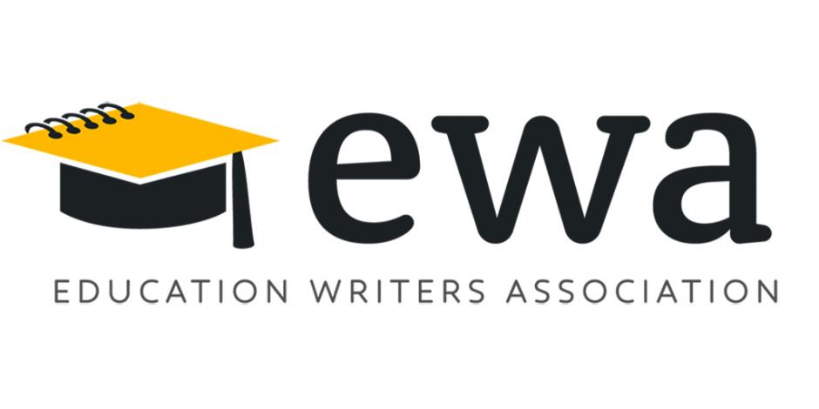
Panelists, including education journalists and subject experts, will share their insights and best practices for covering education issues and producing compelling stories. Among the panelists are:
* Arianna Prothero, Staff Writer, Education Week
* Justin Price, Data Reporter, The Arizona Republic
* Marisol Garcia, Vice President, Arizona Education Association
* Dale Russakoff, freelance writer and author of The Prize, a book about Mark Zuckerberg’s $100 million gift to the Newark, New Jersey, schools
* Dr. Sofia B. Pertuz, Senior Advisor, Campus and Diversity & Inclusion, Jed Foundation
* Janine Menard, Chair, Arizona School Counselors Association
* Matt Beienburg, Director of Education Policy, Goldwater Institute
What: Get Schooled: Covering Education Like A Pro
Who: Arizona Latino Media Association (ALMA) and Education Writers Association (EWA)
When: Saturday, March 2, 2019
Time: 9:00 a.m. to 2:30 p.m.
Where: ASU Walter Cronkite School of Journalism and Mass Communication, 555 N. Central Ave., Phoenix, Ariz.
Cost: FREE, light breakfast and lunch included. Parking: Available for a fee at parking facilities/lots near the Cronkite School. RSVP: https://bit.ly/2UH398K
The Arizona Latino Media Association is a 501(c)3 volunteer organization founded in 1997. Our mission is to create a stronger media industry through diversity initiatives that deepen the scope, coverage and understanding of the Latino community. We consistently seek fair and balanced coverage on issues and topics of importance to the Latino community. In 2015, ALMA became the Phoenix affiliate chapter of the National Association of Hispanic Journalists. As an official NAHJ chapter, ALMA continues to expand and adapt into the changing media environment.
The mission of the Education Writers Association is to strengthen the community of education writers and improve the quality of education coverage to better inform the public. As the professional organization of members of the media who cover education at all levels, EWA has worked for more than 70 years to help journalists get the story right. Today, EWA has more than 3,000 members benefiting from our high-quality programs, training, information, support, and recognition.

